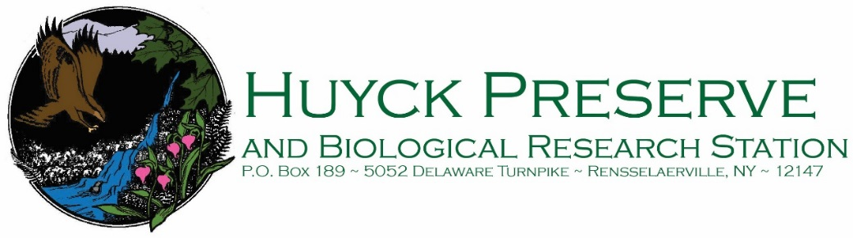

Volunteer Interest Form

Volunteer information
Name: |  |  |  | Phone:
Mailing address: |  |  |  | Date of birth:
Email: |  |  |  | (If under 18 you must have parent or guardian approval)
Have you ever been convicted of a felony? |  |  | Yes |  |  | No
If yes please explain:
Do you have access to transportation to attend training and complete volunteer hours? |  | Yes |  | No

Interests and Skills
Please indicate your skills, hobbies, and certifications by checking or X’ing the boxes next the items below:
 | Birdwatching |  | Plant ID |  | Wildlife ID |  | Education
 | Carpentry |  | Landscaping/Gardening |  | Science research |  | First aid/CPR
 | Hand tools |  | Photography |  | Writing |  | Computer/IT skills
Other skills:
Are you willing and able to walk our trails (which may be several miles) on foot? |  | Yes |  | No
Are you willing and able to interact with Preserve users face to face? |  | Yes |  | No
Are you interested in a regular volunteer shift on a week or monthly basis? |  | Yes |  | No
Please your interest in the following volunteer activities by checking or X’ing the boxes next to the items below:
 | Trail maintenance and checks |  |  | Office work (newsletters and mailings) |  | Visitors center work
 | Computer/IT work |  |  | Citizen science research |  | Special events
 | Other:
Please tell us briefly why you are interested in volunteering at Huyck Preserve:

